[Arduino Uno](https://www.arduino.cc/en/Main/ArduinoBoardUno)

[IBT-2 Web Page](http://www.hessmer.org/blog/2013/12/28/ibt-2-h-bridge-with-arduino/)

[AnalogWrite - PWM](https://www.arduino.cc/en/Reference/analogWrite)

[Voltage Divider Tutorial](https://www.allaboutcircuits.com/textbook/experiments/chpt-3/potentiometer-voltage-divider/)

[Wireless Remote Control](https://docs.google.com/document/d/1AaQmwKiLiiIFLeP8Kk19p4IfnDybd08enQUj-TCrXoc/edit?usp=sharing)

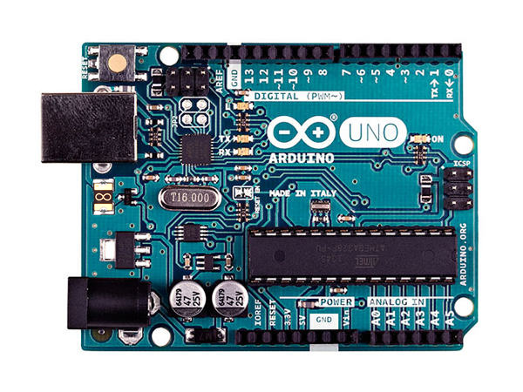

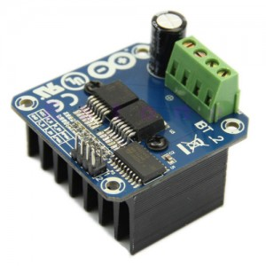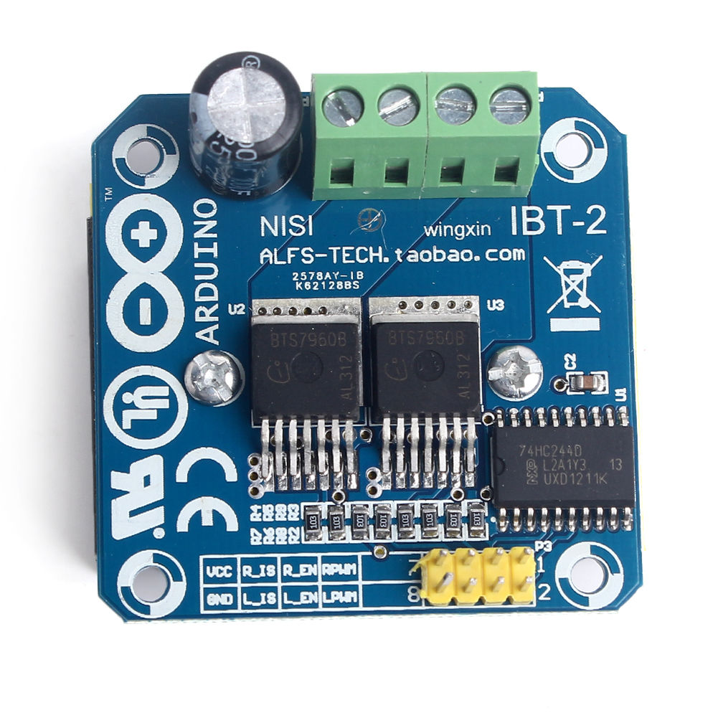

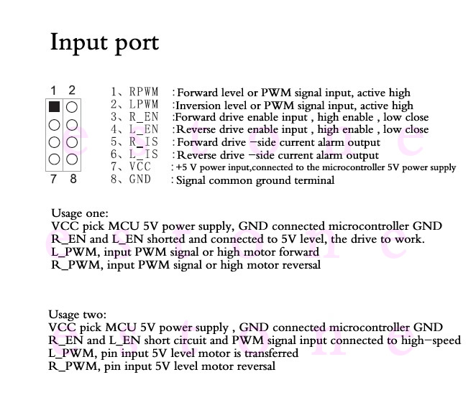

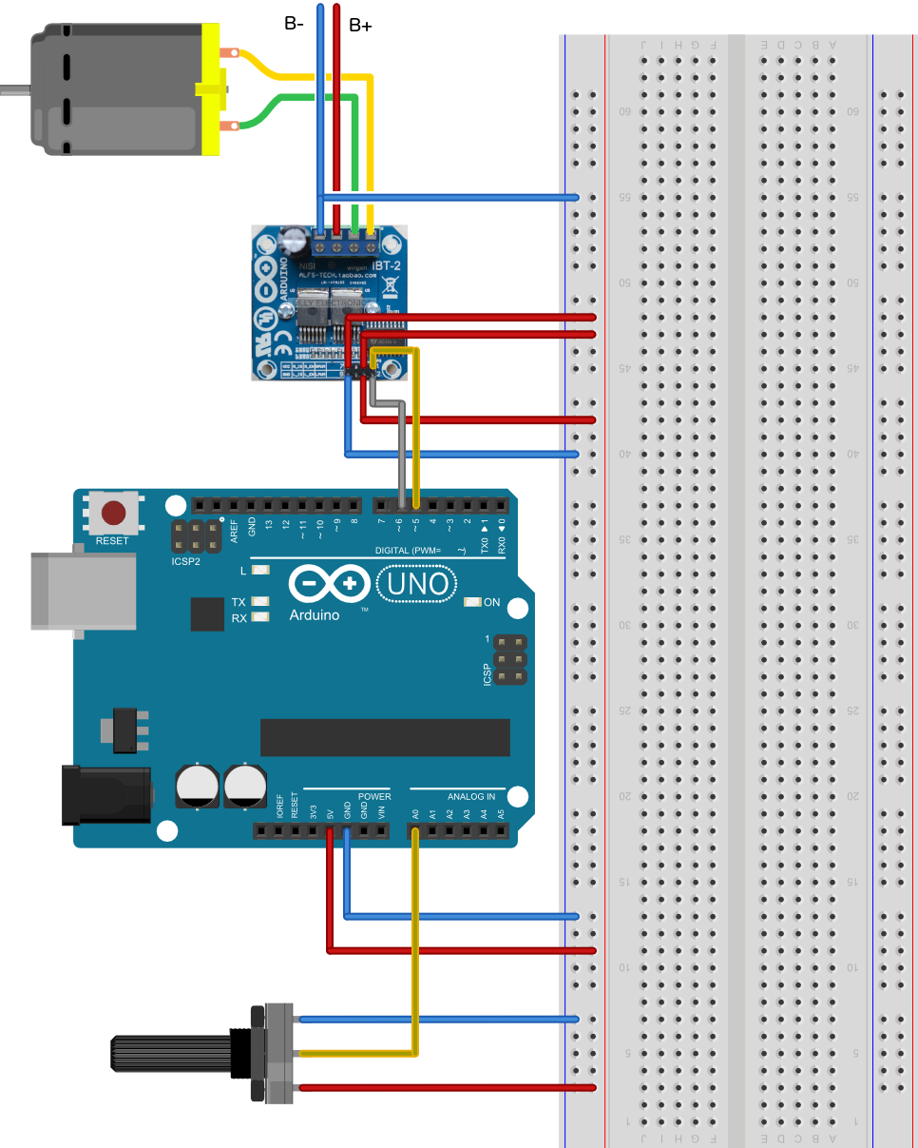

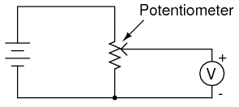

Code for 43 Amp PWM drive.

/*

IBT-2 Motor Control Board driven by Arduino.

Speed and direction controlled by a potentiometer attached to analog input 0.

One side pin of the potentiometer (either one) to ground; the other side pin to +5V

Connection to the IBT-2 board:

IBT-2 pin 1 (RPWM) to Arduino pin 5(PWM)

IBT-2 pin 2 (LPWM) to Arduino pin 6(PWM)

IBT-2 pins 3 (R_EN), 4 (L_EN), 7 (VCC) to Arduino 5V pin

IBT-2 pin 8 (GND) to Arduino GND

IBT-2 pins 5 (R_IS) and 6 (L_IS) not connected

*/

int SENSOR_PIN = 0; // center pin of the potentiometer

int RPWM_Output = 5; // Arduino PWM output pin 5; connect to IBT-2 pin 1 (RPWM)

int LPWM_Output = 6; // Arduino PWM output pin 6; connect to IBT-2 pin 2 (LPWM)

void setup()

{

pinMode(RPWM_Output, OUTPUT); // Pin 5 to Right Output

pinMode(LPWM_Output, OUTPUT); // Pin 6 to Left Output

}

void loop()

{

int sensorValue = analogRead(SENSOR_PIN); // Get Analog Input Value (A0)

// sensor value is in the range 0 to 1023 // Normal range of analog input

// the lower half of it we use for reverse rotation; the upper half for forward rotation (middle value is stop).

if (sensorValue < 512)

{

// reverse rotation 511=zero speed

int reversePWM = -(sensorValue - 511) / 2;

analogWrite(LPWM_Output, 0);

analogWrite(RPWM_Output, reversePWM);

}

else

{

// forward rotation

int forwardPWM = (sensorValue - 512) / 2;

analogWrite(LPWM_Output, forwardPWM);

analogWrite(RPWM_Output, 0);

}

}

## analogWrite()

#### Description

Writes an analog value ([PWM wave](https://www.arduino.cc/en/Tutorial/PWM)) to a pin. Can be used to light a LED at varying brightnesses or drive a motor at various speeds. After a call to analogWrite(), the pin will generate a steady square wave of the specified duty cycle until the next call to analogWrite() (or a call to digitalRead() or digitalWrite() on the same pin). The frequency of the PWM signal on most pins is approximately 490 Hz. On the Uno and similar boards, pins 5 and 6 have a frequency of approximately 980 Hz. Pins 3 and 11 on the Leonardo also run at 980 Hz.